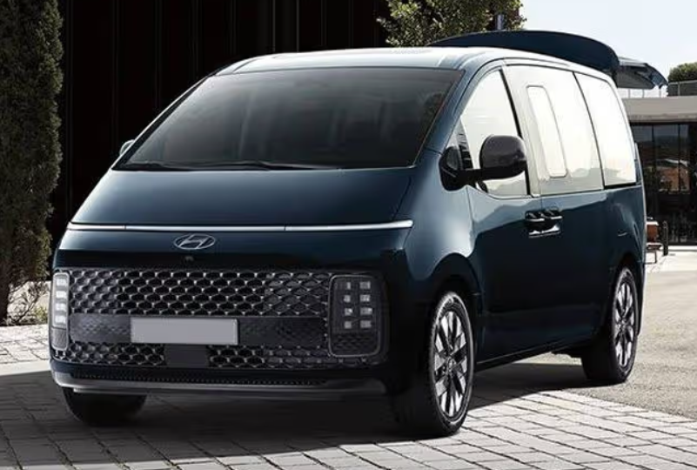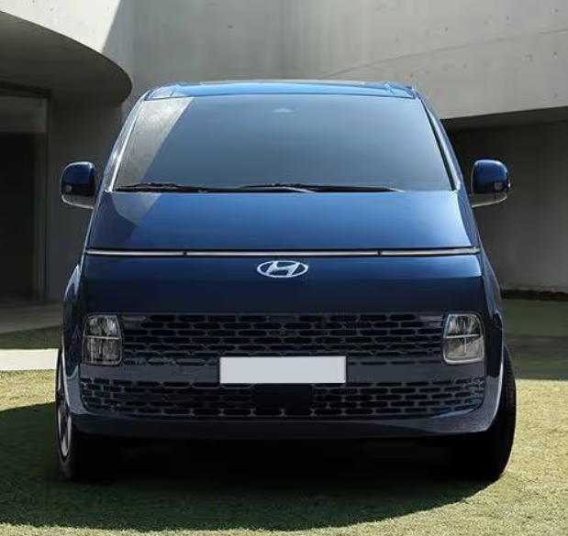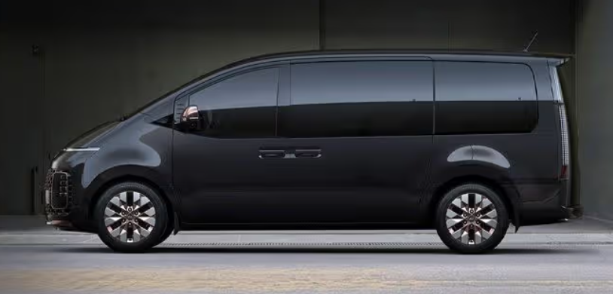

Main specification of Hyundai Staria

**🚗 Engines & Performance**

* **Petrol**: 3.5 L Smartstream G3.5 MPI V6  
  • Power: ~272 hp @ 6,400 rpm  
  • Torque: ~331 Nm @ 5,000 rpm
* **Diesel**: 2.2 L R II CRDi I4  
  • Power: ~177 hp @ 3,800 rpm  
  • Torque: ~430 Nm between 1,500–2,500 rpm
* **Transmissions**:  
  • Petrol: 8‑speed automatic  
  • Diesel: 6-speed manual or 8‑speed automatic
* **Drive**: Front-wheel drive (AWD available in some regions)
* **Top Speed**: ~180–210 km/h depending on engine
* **0‑100 kph (petrol)**: ~8.9 sec

**📏 Dimensions & Capacity**

* **Length × Width × Height**: ~5,253 × 1,997 × 1,990 mm
* **Wheelbase**: ~3,273 mm
* **Ground Clearance**: ~186 mm
* **Kerb Weight**: ~2,220–3,140 kg depending on variant
* **Seating Capacity**: Up to 11 seats (3.5L petrol often limited to 9)
* **Cargo Space**: ~1,024 L behind the last row

**⛽ Fuel Economy & Fuel System**

* **Tank**: ~75 L
* **Mileage**: Petrol ~8 km/L city; Diesel ~10–13 km/L combined

**🛞 Chassis, Brakes & Wheels**

* **Suspension**: Front MacPherson struts; rear multi-link
* **Brakes**: Front and rear disc brakes with ABS/EBD/Brake Assist
* **Wheels/Tires**: 17″ steel or 18″ alloy (235/55 R18)

**🛋️ Interior & Tech**

* **Dashboard**: 8″ or 10.25″ touchscreen infotainment; 10.25″ digital instrument display on higher trims
* **Connectivity**: Wireless Apple CarPlay & Android Auto, Bluetooth, USB-C ports, wireless charging
* **Comfort**: Leather seats (Nappa in some markets), dual-zone climate control, heated/ventilated front seats optional
* **Convenience**: Power sliding doors, power tailgate, paddle shifters, electronic parking brake

**🛡️ Safety**

* **Airbags**: Up to 6 (front, side, curtain)
* **Driver aids**: ABS, EBD, ESC, Traction Control, Hill-Start Assist, Downhill Brake Control
* **Advanced systems**: Surround-view camera, blind-spot detection, lane-keeping, adaptive cruise control available

**🌐 Platform & Build**

* Built on Hyundai‑Kia N3 platform (shared with Santa Fe, Carnival
* Design inspired by a "spaceship‑on‑the‑road", with panoramic windows and futuristic styling

**✅ Summary**

The **Hyundai Staria** offers a versatile package: spacious cabin, striking futuristic design, powerful V6 petrol or torque-rich diesel, and strong tech and safety features. Ideal for large families or fleet use, with modern comfort and convenience.